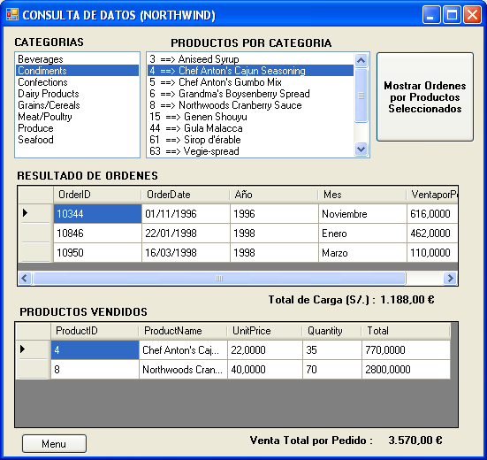
using System;
using System.Collections.Generic;
using System.Text;
using System.Data;
using System.Data.SqlClient;
namespace LIBNEGOCIO
{
public class ClsAplicacion1 {
SqlConnection cn = new SqlConnection(Clsconexion.conexion);
public DataTable MostrarCategorias() {
using (SqlDataAdapter da = new SqlDataAdapter("usp_Categorias", cn))
{
DataTable tbl = new DataTable();
da.Fill(tbl);
return tbl;
}
}

public DataTable ProductosPorCategoria(int ProductId) {
using (SqlCommand cmd = new SqlCommand("usp_ProdporCategoria", cn))
{
cmd.CommandType = CommandType.StoredProcedure;
cmd.Parameters.Add("@CategoryID", SqlDbType.Int).Value = ProductId;
using (SqlDataAdapter da = new SqlDataAdapter(cmd))
{
DataTable tbl = new DataTable();
da.Fill(tbl);
return tbl;
}
}
}

public DataTable OrdenesPorProductos(string IdProducts,
out Double Tventa {
using (SqlCommand cmd = new SqlCommand("usp_OrdenesporProductos", cn))
{
cmd.CommandType = CommandType.StoredProcedure;
cmd.Parameters.Add("@idProductos", SqlDbType.VarChar, 100).Value = IdProducts;
using(SqlDataAdapter da=new SqlDataAdapter(cmd))
{
DataTable tbl = new DataTable();
da.Fill(tbl);
Tventa = Convert.ToDouble(tbl.Compute("sum(VentaporPedido)", ""));
return tbl;
}
}
}

public DataTable ProductosVendidos(int OrderId,
out Double TVentaPedido) {
using (SqlCommand cmd = new SqlCommand("usp_ProductosVendidos", cn))
{
cmd.CommandType = CommandType.StoredProcedure;
cmd.Parameters.Add("@OrderID", SqlDbType.Int).Value = OrderId;

using(SqlDataAdapter da=new SqlDataAdapter(cmd))
{
DataTable tbl = new DataTable();
da.Fill(tbl);
TVentaPedido = Convert.ToDouble(tbl.Compute("Sum(Total)", ""));
return tbl;
}
}
}

}
}

using System;
using System.Collections.Generic;
using System.ComponentModel;
using System.Data;
using System.Drawing;
using System.Text;
using System.Windows.Forms;
namespace Semana_3___LP_VI___LIBNEGOCIO
{
public partial class Form1 : Form
{
public Form1()
{
InitializeComponent();
}
LIBNEGOCIO.ClsAplicacion1 obj = new LIBNEGOCIO.ClsAplicacion1();

private void Form1_Load(object sender, EventArgs e)
{
lstCategorias.DataSource = obj.MostrarCategorias();
lstCategorias.DisplayMember = "CategoryName";
lstCategorias.ValueMember = "CategoryID";
}

private void lstCategorias_Click(object sender, EventArgs e) {
int IdCategoria = int.Parse(lstCategorias.SelectedValue.ToString());
DataTable tbl = obj.ProductosPorCategoria(IdCategoria);
lstProductos.Items.Clear();
for (int i = 0; i < tbl.Rows.Count; i++) {
lstProductos.Items.Add(tbl.Rows[i][0].ToString() + " ==> " +
tbl.Rows[i][1].ToString());
}
}

private void btnMostrar_Click(object sender, EventArgs e)
{//MOSTRAR LAS ORDENES
string codigo = "";
for (int i = 0; i < lstProductos.Items.Count; i++)
{ //preguntamos si el elemento fue seleccionado
if (lstProductos.GetSelected (i))
{ //recuperando los codigos mediante subtracion de cadenas 1,2,3,4
codigo += lstProductos.Items[i].ToString().Substring(0,2).Trim()+",";
}
}
//quitando la coma sobrante 1,2,3
codigo = codigo.Remove(codigo.Length - 1).ToString();
//variable para recuperar el valor del parametro out
double NVenta = 0;
DataTable tbl = obj.OrdenesPorProductos(codigo, out NVenta);
dataGridView1.DataSource = tbl;
LBLCARGA.Text = NVenta.ToString("c"); //c-->formato moneda
}

private void dataGridView1_CellContentClick(object sender, DataGridViewCellEventArgs e)
{
double TVentapedido = 0;
int OrderID =int.Parse(dataGridView1[0,e.RowIndex].Value.ToString());
dataGridView2.DataSource =
obj.ProductosVendidos (OrderID, out TVentapedido);
lblVenta.Text = TVentapedido.ToString("c");
}

private void btnMenu_Click(object sender, EventArgs e)
{
CLip clip = new CLip();
clip.Show();
Hide();
}

}
}

